**A decade of change in NO2 and SO2 over the Canadian oil sands as seen from space**

Chris A. McLinden1, Vitali Fioletov1, Nickolay A. Krotkov2, Can Li2,3, K. Folkert Boersma4,5, Cristen Adams1

1 Air Quality Research Division, Environment Canada, Toronto, Canada.

2 Atmospheric Chemistry and Dynamics Laboratory, NASA Goddard Space Flight Center, Greenbelt, MD, USA.

3 Earth System Science Interdisciplinary Center, University of Maryland College Park, MD USA

4 Royal Netherlands Meteorological Institute (KNMI), De Bilt, The Netherlands.

5 Department of Meteorology and Air Quality, Wageningen University, Wageningen, The Netherlands

**Abstract.**

A decade of observations from the Ozone Monitoring Instrument (OMI), a UV-visible spectrometer on board the NASA Aura satellite, were used to examine tropospheric nitrogen dioxide (NO2) and sulfur dioxide (SO2) vertical column densities (VCDs) over a large region of western Canada and the northern US, with a focus on the Canadian oil sands. Near an area of intensive surface mining within the oil sands, NO2 is seen to be increasing, at some locations by as much as 10%/year, while SO2 shows a slight decline. This is in contrast to trends elsewhere in the region which show substantial declines in both. These disparate trends means the oil sands NO2 and SO2 signals are currently as-large or larger than those from any other single, localized source in the region. The OMI-derived trends were found to be generally consistent with those from the Canadian surface monitoring network, although in the case of SO2, it was necessary to apply a correction in order to remove the residual signal from volcanic eruptions in the OMI data.

**1. Introduction**

The Canadian province of Alberta is home to large deposits of bitumen (a viscous form of oil) mixed with impurities such as sand, clay and water. The equivalent of 170 billion barrels (roughly 2.7×107 m3) of recoverable oil resides in the northeast corner of the province, some 20% located close enough to the surface to be mined, the remaining requiring in-situ extraction techniques. Development and production has increased rapidly since about 2000 and, as of 2013, the equivalent of roughly 2.3 mBPD (million of barrels per day) are extracted over the entire oil sands region. Initially, the focus was on surface mining but, as of 2011-2012, the larger fraction of bitumen is extracted through in-situ methods. Projections suggest the total will reach 4.5 mBPD by 2023.1

There are a variety of environmental and health related concerns associated with the oil sands2,3 with degraded air quality and acid deposition among them. A comprehensive, science-based monitoring plan was implemented in an effort to address some fundamental questions. For the air component these include4: what is being emitted by the oil sands, what is the fate of these emissions, and what is their cumulative environmental effect?

An initial satellite-based investigation undertaken to help address these questions found clear enhancements (where "enhancement" is defined as a statistically significant increase compared to a background level) in tropospheric nitrogen dioxide (NO2) and sulfur dioxide (SO2) over an area of intensive surface mining.5 These compounds are known to have deleterious effects on the environment and human health through their links to smog, formation of particulate matter, and acid rain.6 The present work expands and improves upon this initial study by making use of improved data products. It also uses - for the first time anywhere - a now decade-long time series from the Ozone Monitoring Instrument (OMI), 2005-2014. Furthermore, to help place the oil sands into a regional context, the domain of study, shown in Figure 1, encompasses the Canadian provinces of Alberta, Saskatchewan, and Manitoba as well as portions of the northern United States (46°N-60°N; 95°W-120°W).

**2. OMI Satellite data**

OMI (2004-present), on-board the NASA’s Earth Observing System Aura satellite (http://aura.gsfc.nasa.gov/), is a nadir-viewing spectrometer that measures sunlight in the UV-visible (270-590 nm) reflected off the Earth's surface or scattering by atmospheric molecules and particles.7 Information on reactive trace gases such as NO2, SO2, and others is derived by examining the fine absorption structures in the OMI-recorded nadir spectra and matching them to laboratory-measured reference absorption cross-section data. The abundance of these weakly absorbing species is quantified in terms of a tropospheric vertical column densities (VCDs), or the vertically-integrated number density through the entire troposphere and has units of molecules/cm2 (or in the case of SO2, Dobson Units, DU, where 1 DU = 2.69×1016 molecules/cm2).

Obtaining an accurate VCD requires that the sensitivity of OMI to the absorber being retrieved (i.e., NO2 or SO2) be well represented, and this is dependent on several factors such as such as viewing geometry, height (or distribution with height) of the absorber, reflectivity of the surface, clouds, ozone absorption for SO2. This sensitivity is quantified in terms of air-mass factors (AMFs) for multi-step inversion processes8,9 or Jacobians10 for single-step ones.

This work uses level 2 (orbit-based) VCDs from the two operational NO2 data products, DOMINO v28 and Standard Product (SP) v2.1,9 and a new principle-component analysis (PCA) product,10 recently adopted as the official OMI SO2 product. To each of these, new Environment Canada AMFs were applied11-12; see supporting material), developed to reduce systematic errors in the operational products over the oil sands. For NO2, the mean of the DOMINO and SP data products are used in the analysis as, overall, it was found to be better suited at tracking the change in NO2 as compared to either algorithm individually. Further justification for this is given in the Supporting Information.

Additional information on the data filtering is provided in the supporting material. In short: a radiative cloud fraction upper limit of 0.3 was used and a solar zenith angle limit of 75°/70° was placed on NO2/SO2. Data from OMI track positions affected by the row anomaly (RA) were excluded, and large viewing angles were excluded, so that of the 60 cross-track positions measured by OMI, only positions 11-50 not affected by RA were used which correspond to those with a finer spatial resolution (see Supporting Information). The RA slowly expanded with time and so this led to a substantial decrease in data density in the latter years. Year-round NO2 data were used but, following Fioletov et al.13, only summertime (May-to-August) SO2 data were used as they possesses the best signal-to-noise. Volcanic SO2 was filtered as described in the Supporting Information.

**3. Analysis of OMI observations**

3.1 *Regional Distributions of NO2 and SO2*

Figures 2 and 3 shows maps of regional OMI NO2 and SO2 VCDs averaged over three intervals: 2005-2007, 2008-2010, and 2011-2014. This domain spans a large portion of western Canada (primarily the provinces of Alberta, Saskatchewan, and Manitoba) as well as the northern portion of some US states. This region is sparsely populated (about 6M people over an area of 3M km2) with an economy based largely on agriculture, ranching, and oil production. These maps were generated using the oversampling, or pixel-averaging, method employed in Fioletov et al.13; see supporting material for details on grids and averaging. Also shown in each figure are the locations of significant NOx (the sum of NO and NO2) or SO2 emission sites, colour-coded by category – cities, coal-burning power plants, smelters, oil sands, and hydraulic fracturing. Large sources in this area are sparse and, given their short lifetimes (a few hours13,14), average NO2 and SO2 VCDs appear as a hot-spot ("bulls-eye") or localized enhancement centered over the emission site.

From Figure 2, enhancements in NO2 correspond to the larger cities, most notable Calgary and Edmonton in Alberta (Canada) and Winnipeg, Manitoba (Canada), but smaller cities such as Spokane, Washington (US) can also be identified. There are also hot-spots over several coal-fired power plants and the surface mining region of the oil sands. In the case of SO2, from Figure 3, the enhancements correspond only to industrial locations such as smelting (refining ore into a base metal), the surface mining region of the oil sands and, to a lesser extent, coal-fired power plants. The relatively small SO2 signal from the Canadian power plants is due in part to their burning of low-sulfur coal.

Contrasting the three time intervals reveals, for the most part, an on-going and pronounced decline in both NO2 and SO2, consistent with their trends across North America.13,15-17 In particular, there are significant declines in NO2 near the power plants while SO2 signals have dropped below the OMI detection limit by the 2011-2014 period. In the urban areas the large decreases in NO2 are due primarily to more stringent vehicle emission standards (and this is in spite of a greater number of motor vehicles). The SO2 signature from the large copper smelter in Flin Flon, Manitoba (54.8°N, 101.9°W) is all but gone in the later period, consistent with it being decommissioned in 2010-2011. The 2008-2010 and 2011-2014 SO2 maps also show small artifacts resulting from a combination of decreased data density (due to expansion of the row anomaly) and/or an imperfect filtering of volcanic SO2. It is estimated that the SO2 detection limit is 0.05 DU in the 2005-2007 period and 0.10 DU in the 2011-2014.

One important exception to this rapid overall decline are the oil sands, discussed below.

3.2 *Surface mining*

Average NO2 and SO2 VCD maps over the surface mines are shown inset in Figures 2 and 3, respectively. The outline in each denotes the approximate footprint of the operational surface mines for that time period. Spatial patters are consistent with those from McLinden et al.5; however, the NO2 VCDs are roughly 80% larger and the SO2 are 30% larger as a result of the revised AMFs. McLinden et al.11 found that average NO2 and SO2 surface mixing ratios derived from these VCDs were in good agreement with those from Canadian National Air Pollution Surveillance (NAPS) monitoring stations, suggesting that the EC AMFs are indeed appropriate. Their spatial patterns are also consistent with their known sources: emissions of nitrogen oxides from a combination of the upgrading process and the fuel burned by the large fleet of heavy-hauler trucks. For SO2 emissions are primarily from the upgrading facilities. The SO2 enhancement does not extend as far to the north as NO2, also consistent with its known sources. It also appears to have a larger footprint which is suggestive of a longer lifetime.

Large increases in NO2 between the first two periods are clear; a clear but more modest increase in seen between the second and third periods. This is a consistent with development of the northern half of the surface mining area and an overall increase in the amount of bitumen mined as the large trucks used to transport the bitumen are responsible for a significant fraction of the overall NOx emissions.

The SO2 panels show little change between the 2005-2007 and the 2008-2010 periods, and a slight decline in 2011-2014. While the 2005-2007 period was relatively quiet, there were multiple mid-latitude volcanic eruptions in the other two time periods (e.g., Kasatochi in 2008). The volcanic screening excluded several days following these eruptions in which the plumes drifted over Western Canada. Nonetheless, it appears that artefacts remain (see, e.g., the patches in 2008-2010 over the middle of the domain). As the oil sands region was the primary focus of this work, a local bias correction was only implemented here. Similar to Fioletov et al. (2011), annual average VCDs was calculated considering all points 50-80 km from a reference location in the middle of mining region and then subtracted from all VCDs over the domain shown in the inset panels. The local biases removed for the three periods were 0.0, 0.05, and 0.04 DU.

3.3 *Thermal In-situ Mining Areas*

When the bitumen resides more than 50-100 m below the surface, it becomes impractical to mine it. Instead, alternative technologies such as Steam Assisted Gravity Drainage (SAGD) and Cyclic Steam Stimulation (CSS) (collectively known as 'thermal in-situ' or simply 'in-situ' methods) are necessary. These methods use steam to reduce the viscosity of the bitumen so it can then be pumped to the surface. While surface mining is only carried out near the NE corner of the oil sands region, there is are potential thermal in-situ pockets scattered over the remaining portion of the oil sands.

In addition to the surface mining region, Figures 2 and 3 showed a hint of elevated NO2 in the Cold Lake deposit (see Figure 1) but little else in the way of enhancements. For SO2 this is not surprising since its only significant source is thought to be from upgrading, and these facilities are only present in the surface mining region. However, in-situ mining is expected to be a source of NOx due to the significant amount of natural gas burned to generate the steam. To examine this more closely, mean NO2 VCDs over the oil sands are re-plotted in Figure 4 but with the scale adjusted so that colors vary rapidly between 0.5 and 1.5×1015 cm-2 (where 0.3-0.4 ×1015 cm-2 corresponds to average, background levels found upwind). Much of the Athabasca, and virtually all of the Cold Lake regions, are seen to be above background (see Figure 1). Differentiating the source of this NO2 between mining, local in-situ extraction (and conventional oil and gas) facilities, and downwind transport from the Edmonton area is difficult. However, the clear, local maximum in the Cold Lake region suggests that a sizable portion of what is observed there is emitted locally, and this is consistent with the location of two in-situ operations that emit roughly 10 kt/yr between them, a value that has remained constant over the OMI timeframe. The near zero trend in this area (see also section 3.4, below) indicates that these are largely local emissions as if this were a result of downwind transport from the Edmonton area the trend would reflect its decline.

3.4 *Trends*

A more quantitative evaluation of changes in NO2 and SO2 are shown in Figure 5. Here OMI trends were obtained by calculating monthly-averaged, in the case of NO2, or summer-time-averaged, in the case of SO2, VCDs at each grid box and computing the linear trend between 2005 and 2014. For NO2, constant, linear, and annual harmonic terms were fit to each time series while for SO2 only constant and linear terms were used. Trends in NO2 are given in relative units (%/yr), whereas SO2 trends are only given in absolute units (DU/yr) since the relative trend tends to appear noisy, with artefacts appearing for mean-VCDs near zero. Only trends that are larger than their 1-sigma fitting uncertainty are shown.

Considering NO2 first, values of -3 to -5%/yr are seen over the urban areas and power plants (which translates into a -30% to -50% change over the ten-year lifetime of the OMI mission). There are increases in the oil sands of up to 10%/yr along the eastern edge of the Athabasca region and into the province of Saskatchewan. Note that this increase spans the surface mines as well as the in-situ mining area to the south. This is consistent with the rapid expansion of the in-situ production here which increased from 0.134 to 0.651 mBPD, a 22%/yr increase between 2005 and 2013, due to an increase in SAGD production.1 The increase into Saskatchewan is likely a result of transport across the provincial border. The other oil sands regions, Cold Lake and Peace River, show no significant changes, and this is also broadly consistent with little change in in-situ production here.1

This analysis also reveals another area of increase that was not obvious from Figure 2: the north-west corner of North Dakota. This location corresponds to the Bakken formation (48°N, 103°W), an important new source of oil in the US. With hydraulic fracturing ("fracking") coming of age within the past decade, there has been a rapid increase in oil production from Bakken: 0.2 to 1.0 mBPD between 2009 and 2014.18 Upon closer inspection of Figure 1: the 2005-2007 and 2008-2010 intervals shows that the NO2 here is at or near the background where the 2011-2014 interval shows VCDs are larger, despite a decrease in emissions from the nearby power plants in North Dakota and Saskatchewan. Note that fitting the growth period, 2009-2014, separately would also be instructive.

There are only a few locations with statistically significant trends in SO2. Negative trends occur over power plants and there is a large negative trend over the Flin Flon smelter (resulting from its closure). While a linear trend is not an ideal way to represent a step function, the intent here is only to show that OMI can capture this change. The oil sands show some small negative trends which are only just statistically significant at the 1-sigma level brought about by the slight decline in the 2011-2014 period. Note that without implementing the local bias correction, this location would show a slight positive trend.

The ability of OMI to track changes in NO2 and SO2 was evaluated through comparisons with measurement from NAPS stations over the 2005-2013 time period. For NO2, monthly mean NAPS surface volume mixing were calculated using values only at the OMI overpass time. Monthly mean OMI VCDs were also calculated considering OMI pixels within 15 km of each NAPS station. No NOz-interference correction19 was applied to the photolytic NO2 measurements as the relative high bias from this was assumed to be constant with time. For a given station, only months where both NAPS and OMI had a valid average were retained, with a minimum of 60 such months (from a maximum of 108 months) required. There were 29 stations that met these criteria, five in the oil sands surface mining region. A simple trend model (constant, linear, annual harmonic terms) was fit to each time series and the relative trends were determined. For SO2, summertime (May-August) NAPS and OMI means were used, where the OMI mean VCD was calculated using values within 30 km of the NAPS station. Here, only stations with 8 or more valid summer means which were larger than 0.05 DU and 0.5 ppb were considered. A two-parameter trend model (constant and linear) was used. For stations located in the oil sands, the local bias correction was applied to the OMI SO2 VCDs discussed earlier.

Scatter-plots of OMI vs. NAPS relative trends is shown in Figure 6. From Figure 6a, stations with mean surface NO2 volume mixing ratio (vmr) of 3 ppb or less show a variable proximity to the 1:1 line. In contrast, for stations with a mean of 3 ppb or more there was a good correlation (correlation coefficient of 0.88) and a slope of 0.78. Overall these results indicate that for stations above background, OMI is able to capture the trend whereas at or near background, OMI may have difficulties. Additional work, beyond the scope of this study, is required to elucidate this.

Five stations in Figure 6a are located in and near the surface mining area and these fell close to the 1:1 line, with two stations (Fort McKay and Syncrude UE1) having the largest increases at +4-6%/yr. Figure 5 indicates, however, that the largest relative trends in NO2 are roughly +10%/yr and these appear in the north-east corner of the surface mining region. (These also correspond to the largest absolute trends.)

This is true more generally: the areas with the fastest increase in NO2 are removed from the surface monitoring sites. Perhaps this is because the majority of the stations are disproportionally positioned nearer to the older mining operations and thus are not as well suited to monitoring near the newer ones, which tend to show the larger trends.

Fewer SO2 stations met the screening criteria: nine in the oil sands and two elsewhere. The station with a large negative trend of -30%/yr is located near the now-closed Flin Flon smelter. Again, a linear trend is not strictly appropriate here, but the two data sources show consistency. Most stations in the oil sands show declining trends, qualitatively consistent with a modest decline in SO2 emissions reported to the Canadian National Pollutant Release Inventory (NPRI) database.20 OMI trends are generally consistent, if slightly less negative, than the surface-station-derived trends. Note that OMI can quantify trends at the 0.01 DU/yr level, a result due in large part to the improvements offered by the new PCA retrieval algorithm.10 Finally, without the local bias correction OMI trends would suggest an increase in SO2 over the surface mines, at odds with the negative values from the surface monitors.

3.5 *Animation of NO2 evolution*

An animation showing the evolution of NO2 in the region is included as part of the supplemental material. This movie shows monthly-calculated, two-year running annual mean NO2 VCD distributions. A two year average was chosen as a trade-off between spatial and temporal resolution: reducing the averaging period meant higher noise or a larger averaging radius was necessary. As with Figure 2, the dominant features include a rapid increase in NO2 over the oil sands surface mining area (shown inset) between 2005-2008 in particular, and the development of a 'lobe' of NO2 in the northeast corner over the last 2-3 years. This is contrasted by the steady decline throughout virtually all of the remainder of the domain except with the exception of the Bakken area which increases beginning in 2011.

**4. Summary**

A decade of observations from the Ozone Monitoring Instrument (OMI), a UV-visible spectrometer on board the NASA's EOS Aura satellite, were used to examine nitrogen dioxide (NO2) and sulfur dioxide (SO2) vertical column densities (VCDs) over a large region of western Canada and the northern US, with a focus on the Canadian oil sands. Near the area of intensive surface mining within the oil sands, NO2 is seen to be increasing, at some locations by up to +10%/year, while SO2 has declined slightly. This is in contrast to trends elsewhere in the region which show substantial declines in NO2 and SO2. These disparate trends means the oil sands NO2 and SO2 signals from OMI are currently as large or larger than those from any other single localized source in the region. Note that this finding does not necessarily translate into surface-levels as OMI captures the entire column. The OMI-derived trends were found to be generally consistent with those from the Canadian surface monitoring network, although in the case of SO2, it was necessary to apply a correction in order to remove the residual effects of volcanic signals.

Enhanced NO2 above background levels are also seen throughout much of the Athabasca and Cold Lake deposits from in-situ mining, with the Athabasca levels increasing rapidly. It is noted that the oil sands is an exemplar of how satellite remote sensing can fill in the picture provided by conventional, ground-based monitoring. In this case, the results presented herein are not necessarily inconsistent with those derived from surface station measurements21, it is simply that conventional monitoring misses the largest increases in NO2.

**Acknowledgements.** This study was supported in part by the Joint Canada-Alberta Implementation Plan for Oil Sands Monitoring. We acknowledge the free use of tropospheric NO2 column data from the OMI sensor from [www.temis.nl](http://www.temis.nl). We also acknowledge the NASA Earth Science Division for funding of OMI NO2 and SO2 products development and analysis. The Dutch‐Finnish‐built OMI instrument is part of the NASA EOS Aura satellite payload. The OMI project is managed by KNMI and the Netherlands Agency for Aerospace Programs (NIVR). The Blue Marble: Next Generation image used as a background in some of the figures is from NASA’s Earth Observatory http://visibleearth.nasa.gov/view\_cat.php?categoryID=1484/)

**References**

(1) ERCB (Energy Resources Conservation Board) (2014), ST98-2014: Alberta’s Energy Reserves 2013 and Supply/Demand Outlook 2014–2023, Calgary, Alberta: Energy Resources Conservation Board. (http://www.aer.ca/data-and-publications/statistical-reports/st98)

(2) Kelly, E. N., et al., Oil sands development contributes elements toxic at low concentrations to the Athabasca River and its tributaries, Proc. Nat. Academy Sci., 107, 16178–16183, 2010.

(3) Galarneau, E.; Hollebone, B. P.; Yang, Z.; Schuster, J.; Preliminary measurement-based estimates of PAH emissions from oil sands tailings ponds. Atmos. Env., **97**, 332-335, 2014.

(4) Abbatt, J., J. Aherne, C. Austin, C. Banic (Ed.), P. Blanchard, J. P. Charland, E. Kelly, S. M. Li, P. Makar, R. Martin, K. McCullum, K. McDonald, C. McLinden, C. Mihele, K. Percy, G. Rideout, J. Rudolph, M. Savard, D. Spink, R. Vet, J. Watson, Integrated Monitoring Plan for the Oil Sands Air Quality Component, 2011 <http://www.ec.gc.ca/default.asp?lang=En&n=56D4043B-1&news=7AC1E7E2-81E0-43A7-BE2B-4D3833FD97CE>

(5) McLinden, C. A.; Fioletov, V.; Boersma, K. F.; Krotkov, N.; Sioris, C. E.; Veefkind, J. P.; Yang, K.; Air quality over the Canadian oil sands: A first assessment using satellite observations. Geophys. Res. Lett., **39**, L04804, doi:10.1029/2011GL050273, 2012.

(6) Simpson, I. J.; Marrero, J. E.; Batterman, S.; Meinardi, S.; Barletta, B.; Blake, D. R.; Air quality in the Industrial Heartland of Alberta, Canada and potential impacts on human health. Atmos. Env., **81**, 702-709, doi:10.1016/j.atmosenv.2013.09.017, 2013.

(7) Levelt, P. F.; van den Oord, G. H. J.; Dobber, M. R.; Mälkki, A.; Visser, H.; de Vries, J.; Stammes, P.; Lundell, J. O. V.; Saari, H.; The Ozone Monitoring Instrument. *IEEE Trans. Geosci. Remote Sens.*, **44**, 1093-1101, 2006.

(8) Boersma, K. F.; Eskes, H. J.; Dirksen, R. J.; van der A, R. J.; Veefkind, J. P.; Stammes, P.; Huijnen, V.; Kleipool, Q. L.; Sneep, M.; Claas, J.; Leitão, J.; Richter, A.; Zhou, Y.; Brunner, D.; An improved tropospheric NO2 column retrieval algorithm for the Ozone Monitoring Instrument, *Atmos. Meas. Tech.*, **4**, 1905-1928, doi:10.5194/amt-4-1905-2011, 2011.

(9) Bucsela, E. J.; Krotkov, N. A.; Celarier, E. A.; Lamsal, L. N.,; Swartz, W. H.; Bhartia, P. K.; Boersma, K. F.; Veefkind, J. P.; Gleason, J. F.; Pickering, K. E.; A new stratospheric and tropospheric NO2 retrieval algorithm for nadir-viewing satellite instruments: applications to OMI. *Atmos. Meas. Tech.*, **6**, 2607-2626, doi:10.5194/amt-6-2607-2013, 2013.

(10) Li, C.; Joiner, J.; Krotkov, N. A.; Bhartia, P. K.; A fast and sensitive new satellite SO2 retrieval algorithm based on principal component analysis: Application to the ozone monitoring instrument. *Geophys. Res. Lett.*, **40**, 6314–6318, doi:10.1002/2013GL058134, 2013.

(11) McLinden, C. A.; Fioletov, V.; Boersma, K. F.; Kharol, S. K.; Krotkov, N.; Lamsal, L.; Makar, P. A.; Martin, R. V.; Veefkind, J. P.; Yang, K.; Improved satellite retrievals of NO2 and SO2 over the Canadian oil sands and comparisons with surface measurements. *Atmos. Chem. Phys.*, **14**, 3637-3656, doi:10.5194/acp-14-3637-2014, 2014.

(12) Stroud, C.; Zaganescu, A., C. ; Chen, J.; McLinden, C. A.; Wang, D.; Regional Air Quality Modelling of Toxic Volatile Organic Air Pollutants across Canada: A Focus on Benzene, 1,2,4-Trimethybenzene,1,3-Butadiene, Formaldehyde, Acetaldehyde and Acrolein. *J. Atmos. Chem.*, submitted, May 2015.

(13) Fioletov, V. E., C. A. McLinden, N Krotkov, M. D. Moran, and K. Yang (2011), Estimation of SO2 emissions using OMI retrievals, Geophys. Res. Lett., 38, L21811, doi:10.1029/2011GL049402.

(14) Fioletov, V. E; McLinden, C. A.; Krotkov, N.; Li, C.; Lifetimes and emissions

of SO2 from point sources estimated from OMI. Geophys. Res. Lett., **42**,

doi:10.1002/2015GL063148, 2015

(15) Russell, A. R., L. C. Valin, and R. C. Cohen, Trends in OMI NO2 observations over the United States: effects of emission control technology and the economic recession, Atmos. Chem. Phys., 12, 12197–12209, 2012.

(16) Lamsal, L. N., Bryan N. Duncan, Yosuko Yoshida, Nickolay A. Krotkov, Kenneth E. Pickering, David G Streets, Zifeng Lu, U.S. NO2 trends (2005–2013): EPA Air Quality System (AQS) data versus improved observations from the Ozone Monitoring Instrument (OMI), Atm Env, 2015.

(17) NASA, New NASA Images Highlight U.S. Air Quality Improvement, <http://www.nasa.gov/content/goddard/new-nasa-images-highlight-us-air-quality-improvement/>, last accessed : 28 May 2015.

(18) EIA (US Energy Information Administration) (2014), Bakken fuels North Dakota’s oil production growth, http://www.eia.gov/todayinenergy/detail.cfm?id=17391, last access: 28 May 2015.

(19) Lamsal, L. N.; Martin, R. V.; van Donkelaar, A.; Celarier, E. A.; Bucsela, E. J.; Boersma, K. F.; Dirksen, R.; Luo, C.; Wang, Y.; Indirect validation of tropospheric nitrogen dioxide retrieved from the OMI satellite instrument: Insight into the seasonal variation of nitrogen oxides at northern midlatitudes. *J. Geophys. Res.*, **115**, D05302, doi:10.1029/2009JD013351, 2010.

(20) NPRI (National Pollutant Release Inventory): 2011. Nitrogen oxide and sulfur oxide emissions for Canada: http://www.ec.gc.ca/pdb/websol/querysite/query\_e.cfm, last access: 28 May 2015.

(21) Bari, M.; Kindzierski, M. B; Fifteen-year trends in criteria air pollutants in oil sands communities of Alberta, Canada. *Env. Int.*, **74**, 200-208, 2015.

|  |  |
| --- | --- |
| oilsands2_marble.png | oilsands2_provstate.png |

Figure 1: left: Map of North America showing the locations of interest in this work: the study domain is contained within the green line; the yellow line shows the Alberta, Canada provincial border, and the filled, colored areas are official oil sands regions: the Athabasca deposits (red), the Cold Lake deposits (blue), and the Peace River deposits (cyan). right: Study domain showing Canadian provincial and US state borders.

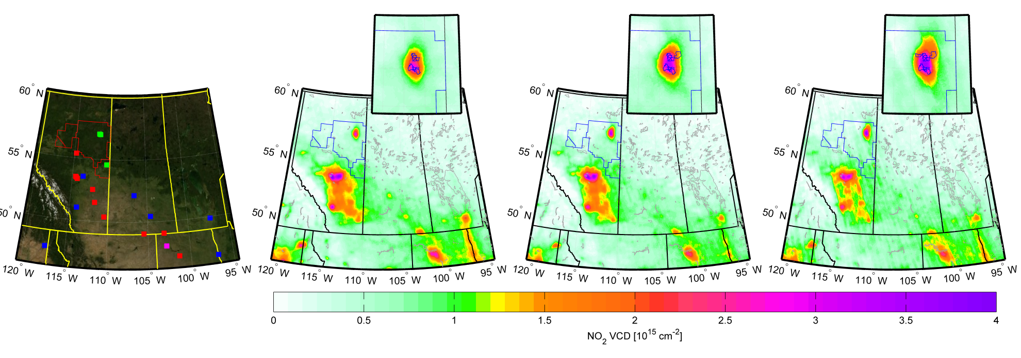

Figure 2. (a) The domain under consideration with the type and location of significant NOx sources circles (blue=cities, red=power plants, cyan=smelters, green=oil sands, magenta=hydraulic fracturing). Panels (b) and (c) show the average NO2 VCDs for the periods 2005-2007 and 2011-2014, respectively. In all panels the blue line represents the boundary of the oil sands region. Inset in panels (b) and (c) are enlargements of the surface mining region of the oil sands.

.

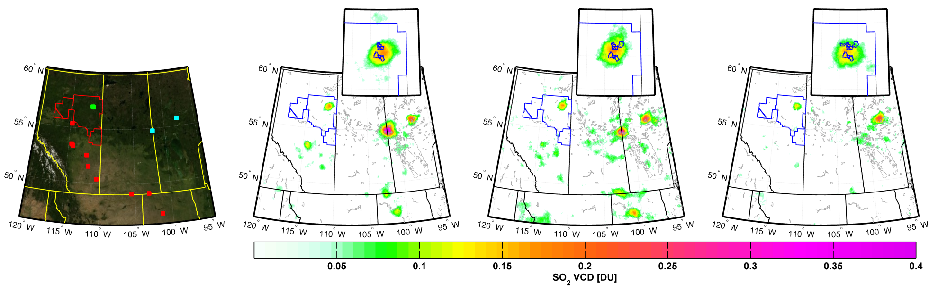

Figure 3. (a) The domain under consideration with the type and location of significant SO2 sources circles (blue=cities, red=power plants, cyan=smelters, green=oil sands, magenta=hydraulic fracturing). Panels (b) and (c) show the average SO2 VCDs for the periods 2005-2007 and 2011-2014, respectively. In all panels the blue line represents the boundary of the oil sands region. Inset in panels (b) and (c) are enlargements of the surface mining region of the oil sands.

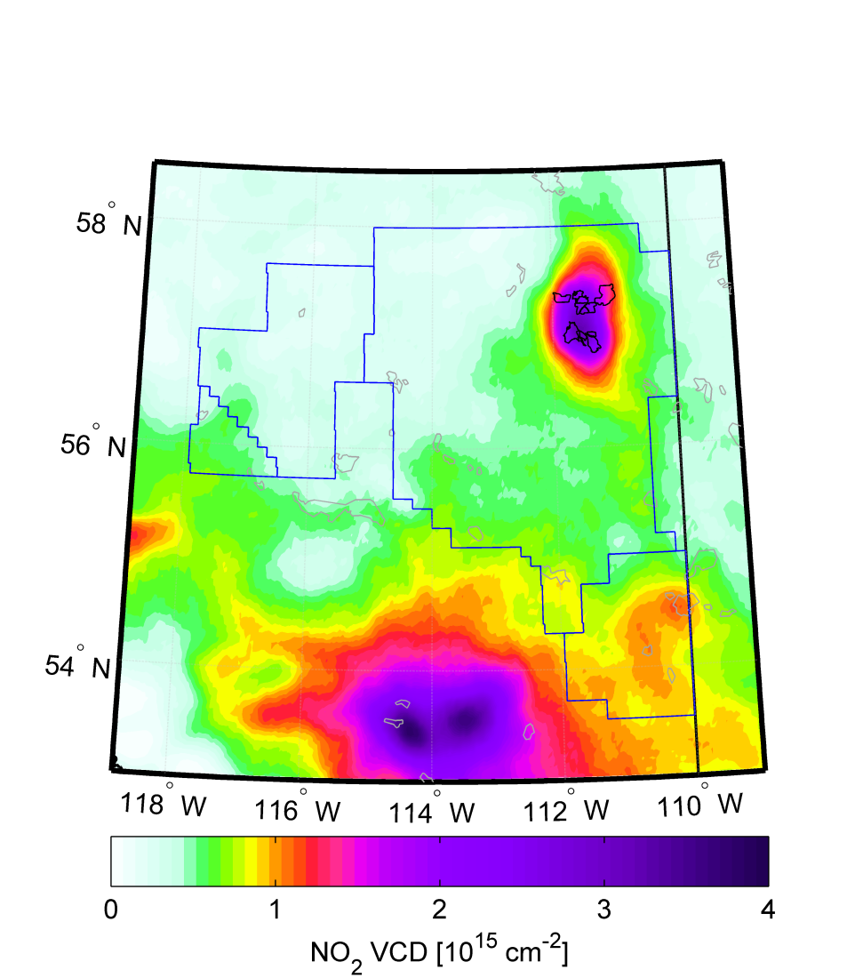

Figure 4: Mean (2005-2014) NO2 VCD over the oil sands with the colorscale adjusted to highlight smaller VCD values. The blue line represents the boundary of the oil sands region, and the black line in the NE corner shows the outline of the surface mining operations. The dual-maxima in the south correspond to the city of Edmonton (right) and a cluster of 4 power plants (left).

|  |  |
| --- | --- |
| OMI_NO2_trend_1sig.png | OMI_SO2_trend_1sig.png |

Figure 5: OMI 2005-2014 linear trends based on annual mean VCDs: (a) NO2 absolute trends, (b) SO2 absolute trends. Only locations in which the trend was larger than its 1-sigma uncertainty are shown. In panel (a) locations where the mean VCD was less than 3×1014 molecules/cm2 were also excluded.

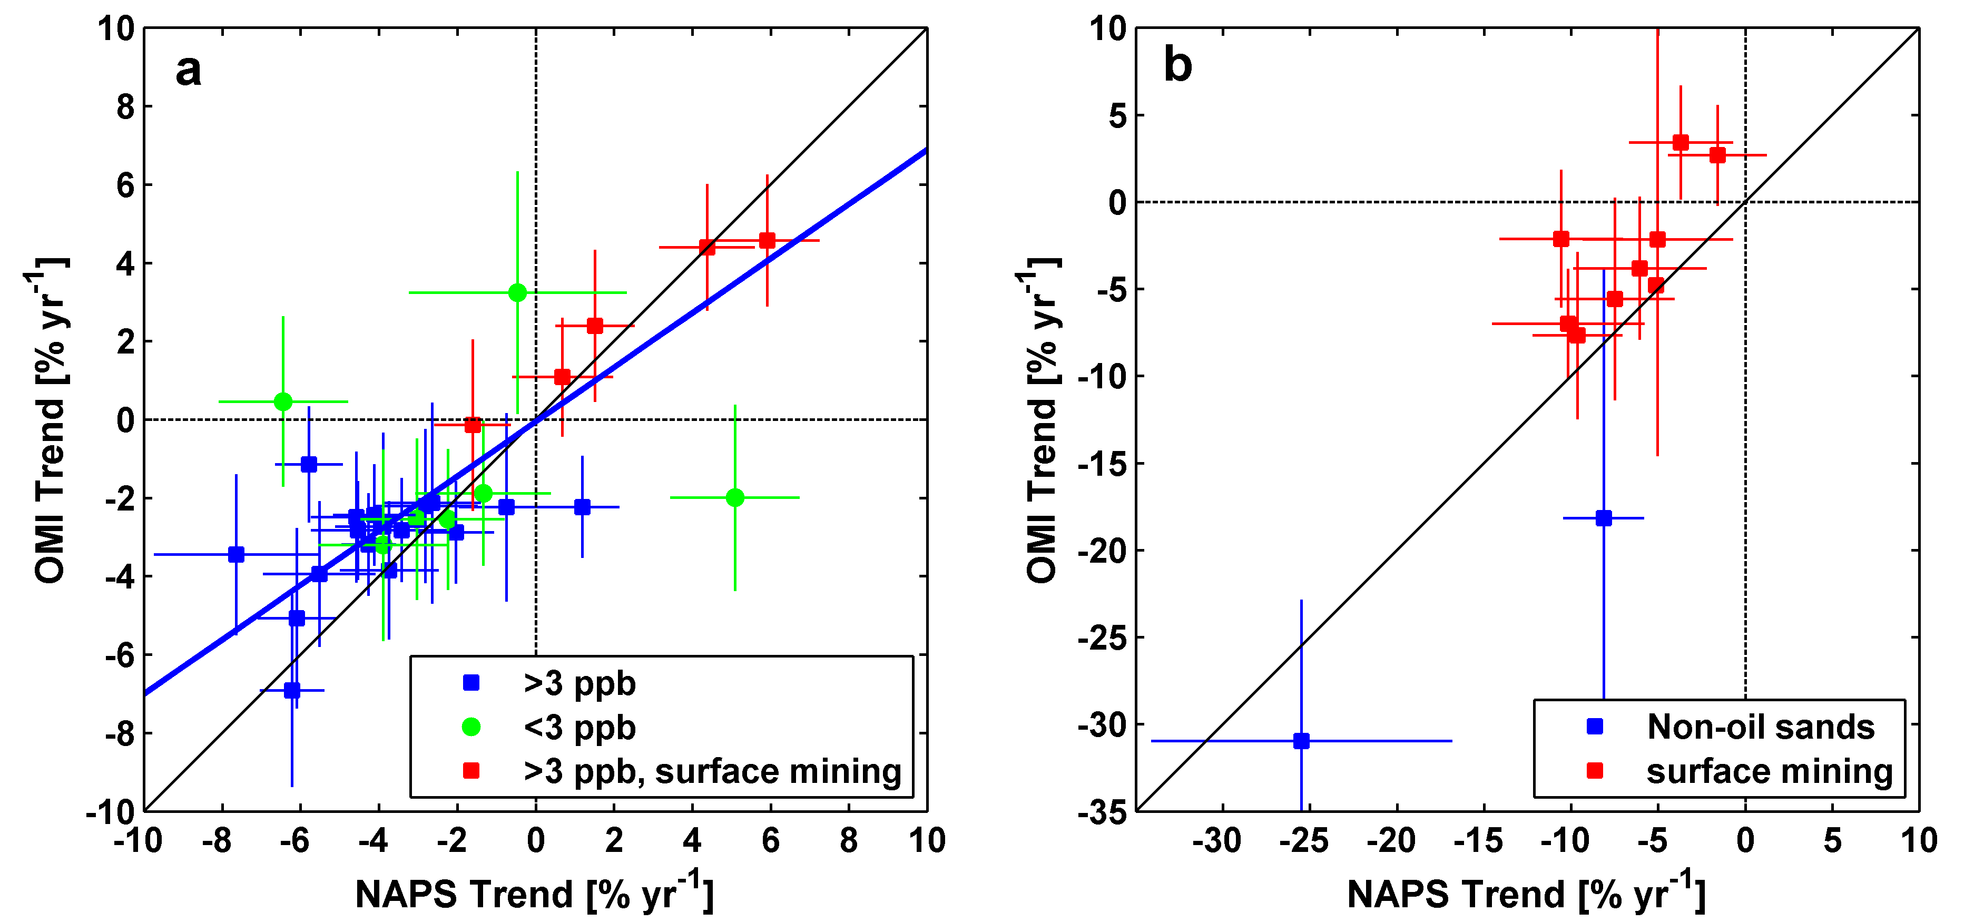

Figure 6: (a) Comparison of 2005-2013 OMI VCD and NAPS surface mixing ratio relative NO2 trends. Results from 29 NAPS stations are shown. The error bars represent the 1-sigma uncertainty in trend. The red squares indicate stations in the oil sands surface mining region. The overall correlation coefficient is 0.71 but if only NAPS stations with average mixing ratios larger than 3 ppb are considered the correlation coefficient is 0.87. The blue line is a linear fit to NAPS stations with a >3 ppb and it has a slope of 0.78. (b) As (a) but for relative SO2 trends at 11 NAPS stations. Only stations with an average VCD of 0.05 DU and an average mixing ratio of 0.5 ppb or larger are plotted. A local bias correction was applied to OMI VCDs (see text) to remove the remaining volcanic signature present in the later years.